AI-Deep Learning 2023(Final) Exam time (9:20-11:20)

1. (30%) Given an LSTM model as shown in Figure 1, point out (i.e., write down the symbols) which is the input gate, output gate, and forget gate, respectively (10%). Then explain the function of each gate (10%). Suppose that we have an application that needs to predict an output y for a sequence of three inputs (x1, x2, x3) (i.e., three time steps); draw an unfolded figure of LSTM for this application. (10%)

ft: forget gate, for controlling the amount of information of the cell state “flow in the current state” from the previous state

it: input gate, for controlling the amount of the contribution to the current cell state by the current input.

ot: output gate, for controlling the amount of state information of the cell state to hidden state.

at: used to be called gate gate, which is a tanh activation function to suppress the contribution of the input between -1 and +1.

So totally, we have four different gates and their corresponding parameter matrices.

For the described application, the layout of the LSTMs are as follows:

ft：忘記門，用於控制單元狀態“當前狀態”與前一個狀態的資訊量

IT：輸入門，用於控制當前輸入對當前單元狀態的貢獻量。

OT：輸出門，用於控制單元狀態到隱藏狀態的狀態資訊量。

AT：以前稱為柵極門，它是一種 tanh 啟動函數，用於抑制 -1 和 +1 之間的輸入貢獻。

因此，我們總共有四個不同的門及其相應的參數矩陣。

對於所描述的應用程式，LSTM 的佈局如下：

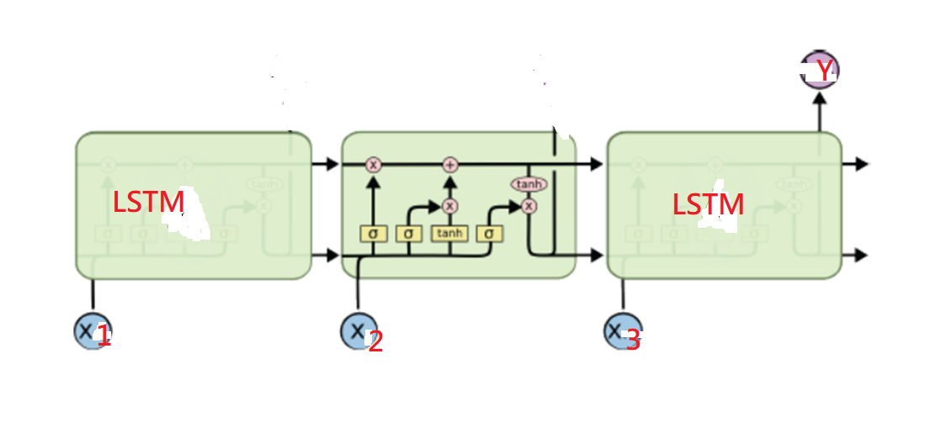

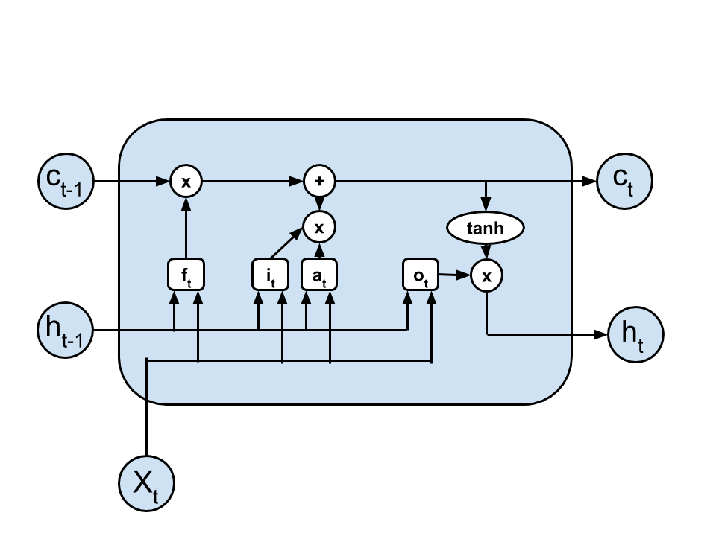

Figure 1. LSTM

1. (10%) What is the problem with a simple (or vanilla) RNN? How to solve it?

The answer is (答案是:): It may cause the gradient vanishing or grading exploding problems. Use “gradient clipping” to solve the gradient exploding problem and use LSTM or GRU to solve the gradient vanishing problem. 它可能會導致梯度消失或分級爆炸問題。使用「梯度裁剪」求解梯度爆炸問題，使用LSTM或GRU求解梯度消失問題。

1. (10%) (下面兩個圖中，何者有使用Attention---The answer is b)The following diagrams show a sequence-to-sequence translation application of an RNN with or without using attention. Point out which (Fig.2(**a)** or Fig.2(**b**) is the RNN with attention model and which is not. Explain what is the difference between them. 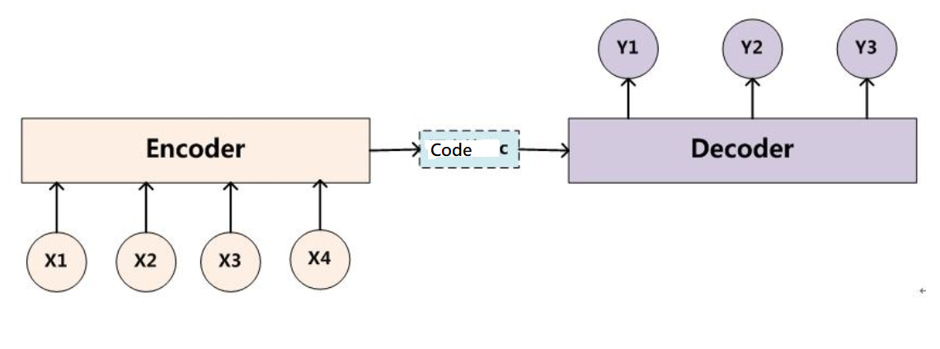Fig. 2(a)

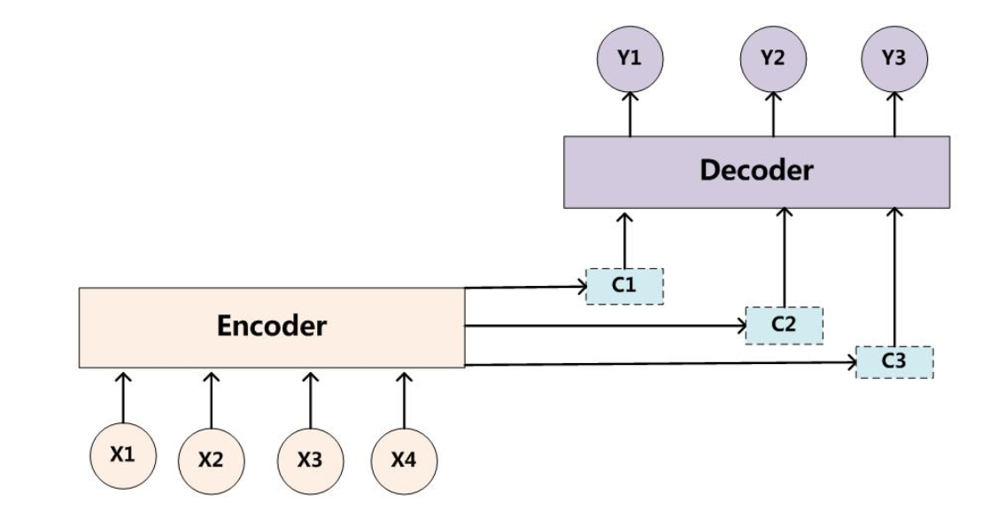

√ Fig. 2(b)

4. (20%) (RNN計算範例)A simple RNN with an initial hidden state of h0=[0.0, 0.0], U=[0.5,0.6], V=[1.0,2.0], Hidden layer bias=[0.1,-0.1], Output bias=[0.1]

W = [0.1,0.2]

    [0.3,0.4]

**Given the input vector [2, 3], calculates the corresponding output of y.**

*For your reference, note that the activation function f is tanh().*

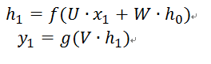

An example of calculation is shown in the following figure.

The answers are: (答案是:) 2.5, 3.0

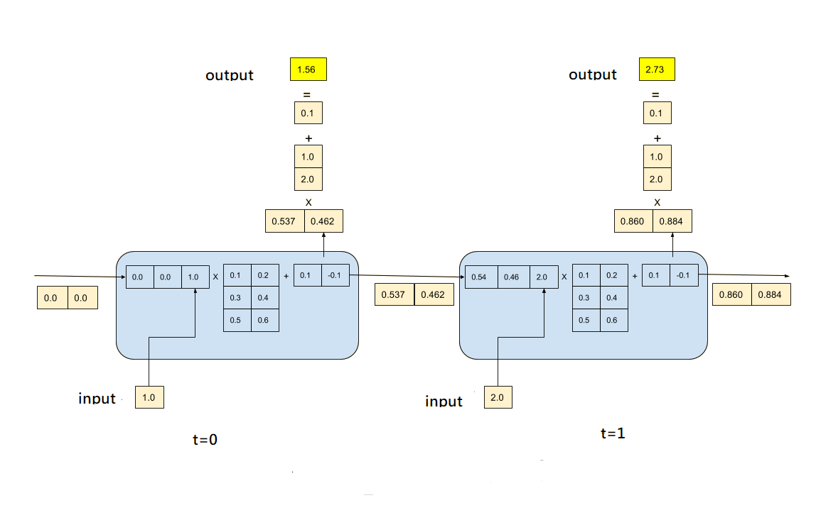

5. (20%)The following piece of code defines a deep LSTM model for a time series prediction. It uses three time steps of historical time series values to predict the value of the next time step.

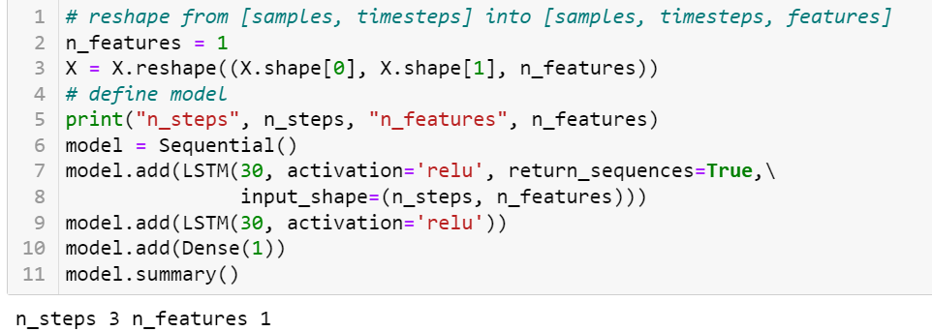

Answer the following questions:

1. How many parameters are there in the first LSTM layer?
2. How many parameters are there in the second LSTM layer?

*Hint: The input of the first layer is just a real number, and the input of the second layer is the hidden vector of the first layer, which has a dimension of 30.*

The answers are(答案是:) (a) 3840 (b) 7320

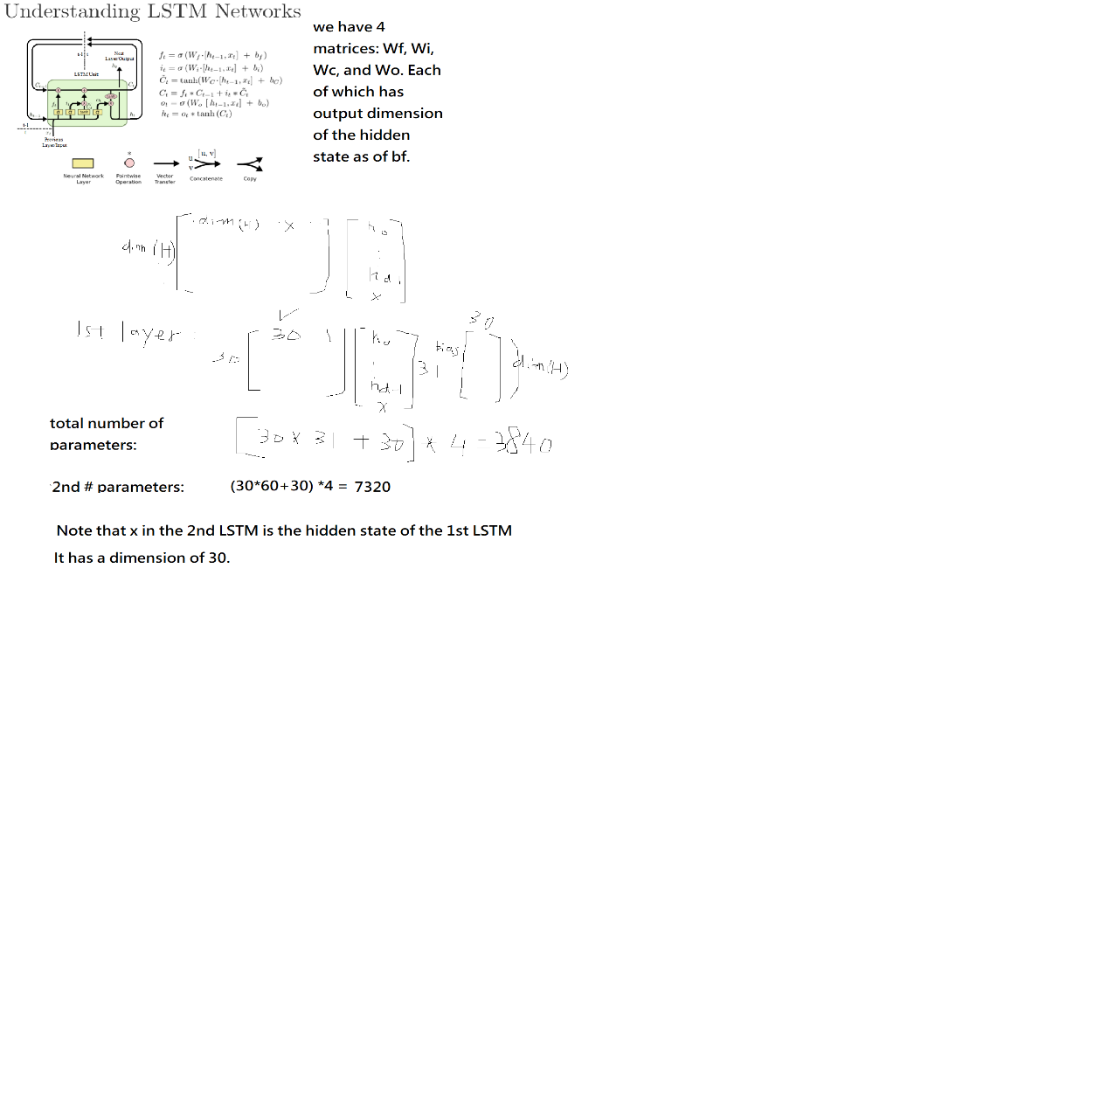

6. (10%) Transformer is the foundation of the many recent large pre-trained language models, such as BERT and ChatGPT. The concept of self-attention is the core of the Transformer. Based on the following figure, please explain the relationships among query, key, value and the resulting representation Z. Please answer this question by considering only one-head attention. *Specifically, please answer how Z's first row is derived from v1 and v2.*

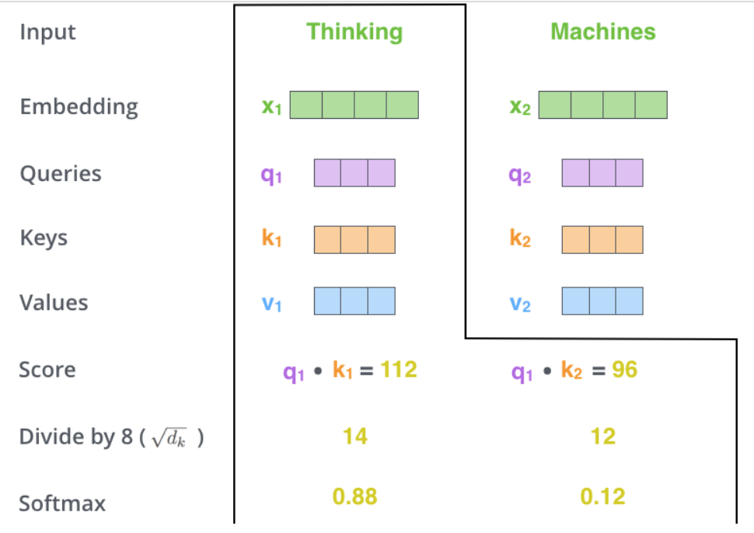

The answer is : Z1= 0.88 * v1 +0.12 * v2

